**Objective –**

**To find a proper place of residence near Seneca College – York Campus enabling safer and secure travelling for Mukta**

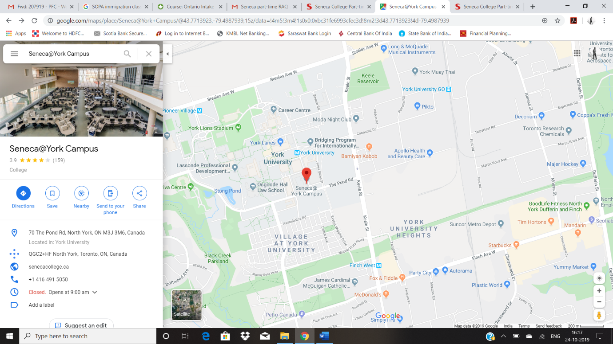**Seneca@York address - 70 The Pond Rd, North York, ON M3J 3M6, Canada**

**Our Requirement – 1 BHK apartment or Condo**

**Our Budget – CAD 1700 – 2000 per month – Incl. Utilities**

|  |  |  |  |  |
| --- | --- | --- | --- | --- |
| **Distance of Seneca@York from various locations** | | | | |
| **Place** | **By Public Transport** | **Nearest Subway/ Bus Stop** | **By Private Transport** |
| Nikhil’s current place | 1 hour | Walk – Bus – Subway – Walk | 24 mins |
| AirBnB | 40 mins | Walk – Bus – Subway – Walk | 18 mins |
| Ipsos Toronto office | 58 Mins | Walk – Subway – Walk | 40 mins |
| Nielsen Markham Office | 1 hour 10 mins | Walk – Bus – Subway – Walk | 26 Mins |
| Nielsen Yonge street office | 1 hour | Walk – Bus – Subway – Walk | 26 Mins |
|  |  |  |  |
|  |  |  |  |